**AWS system manager parameter store**

**1. Create parameter in development level.  
2.AWS Systems Manager → Parameter Store → /my-app/dev/db-url**

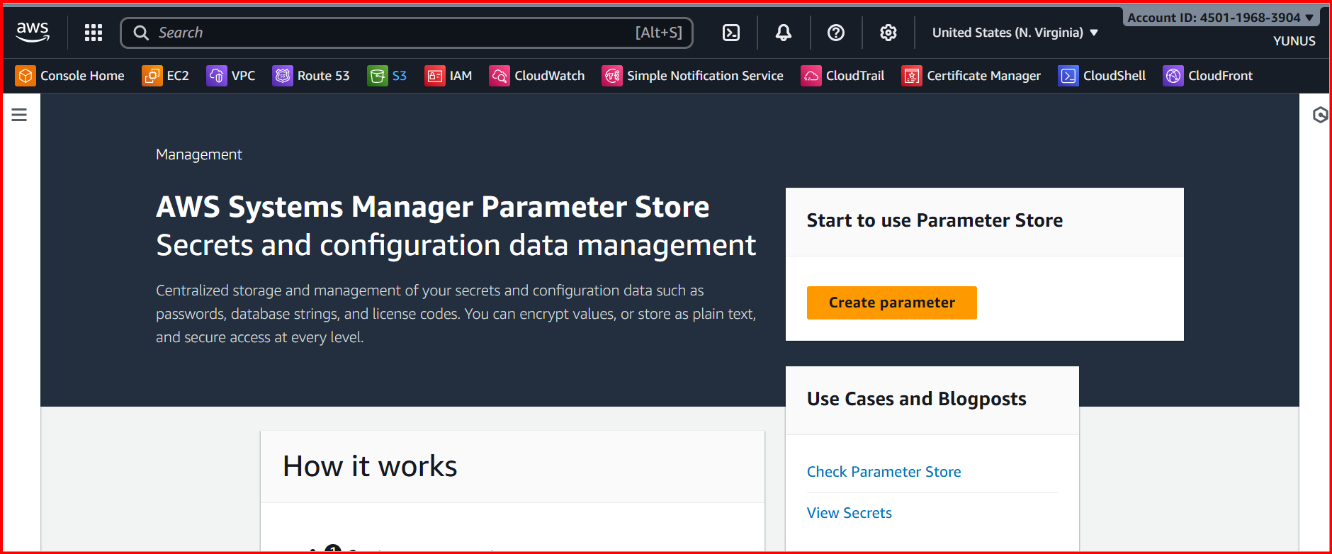

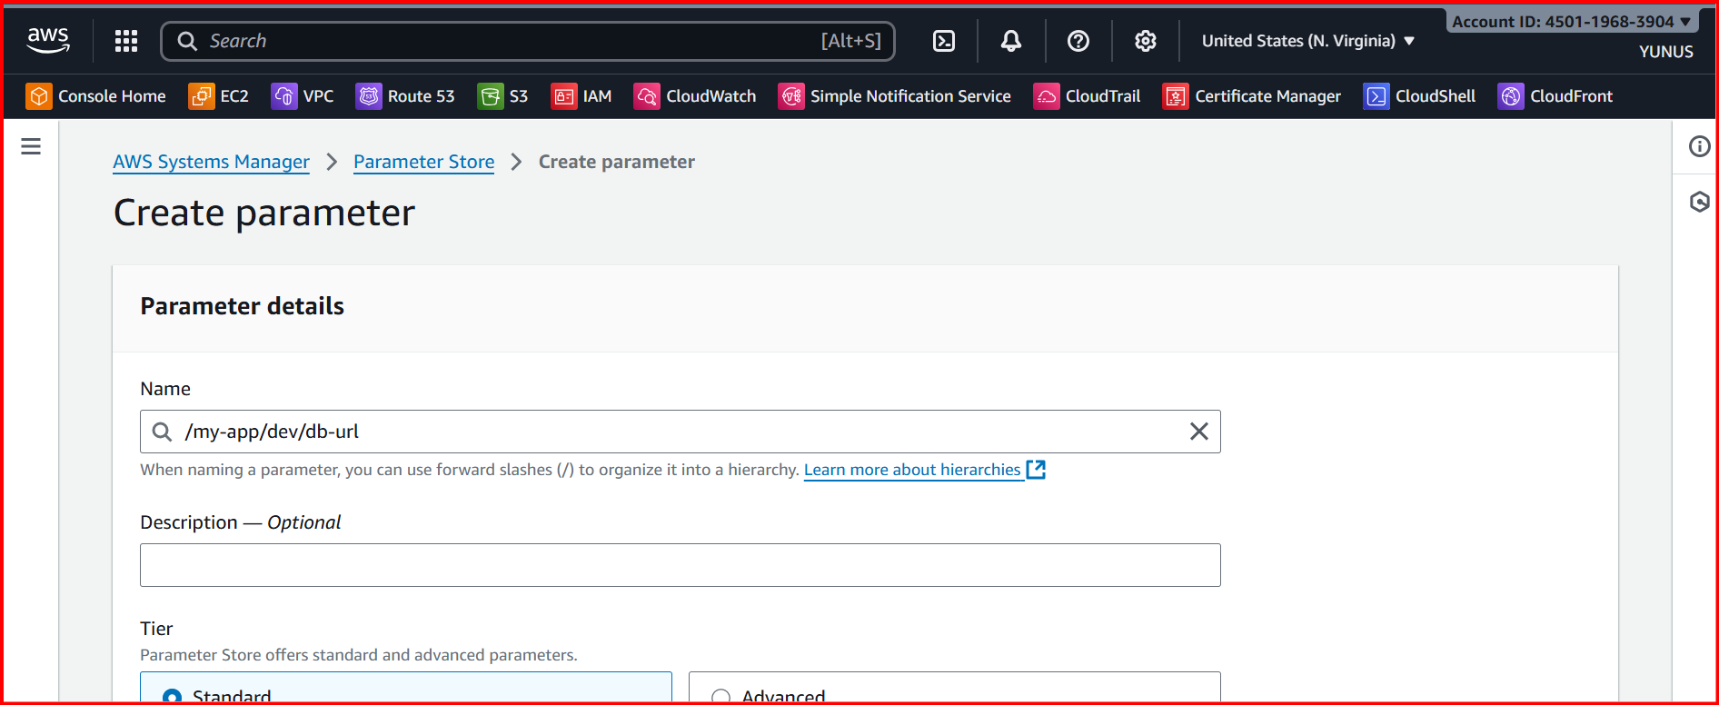

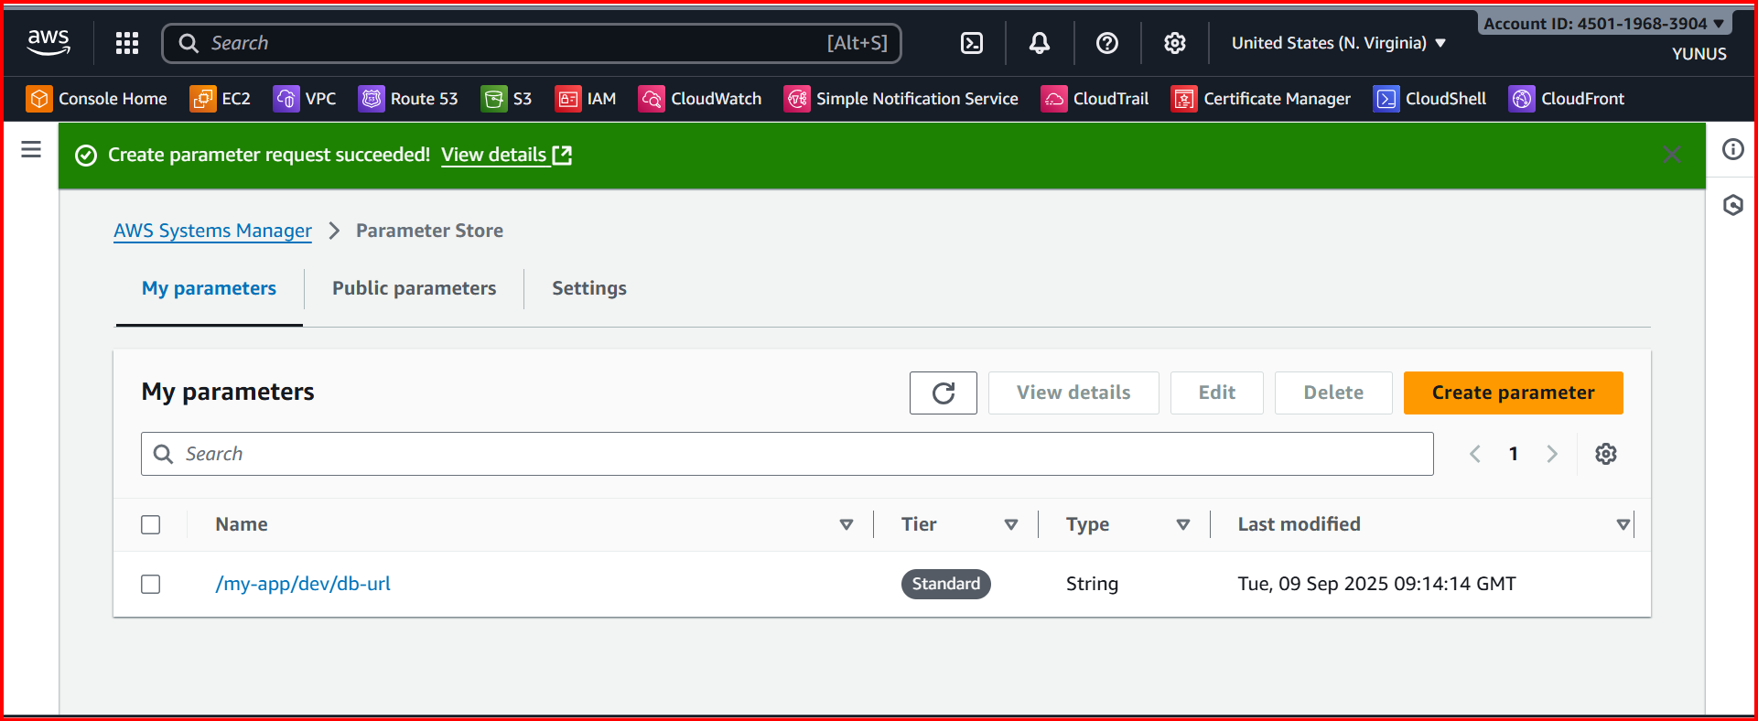

**And create another parameter for app password**

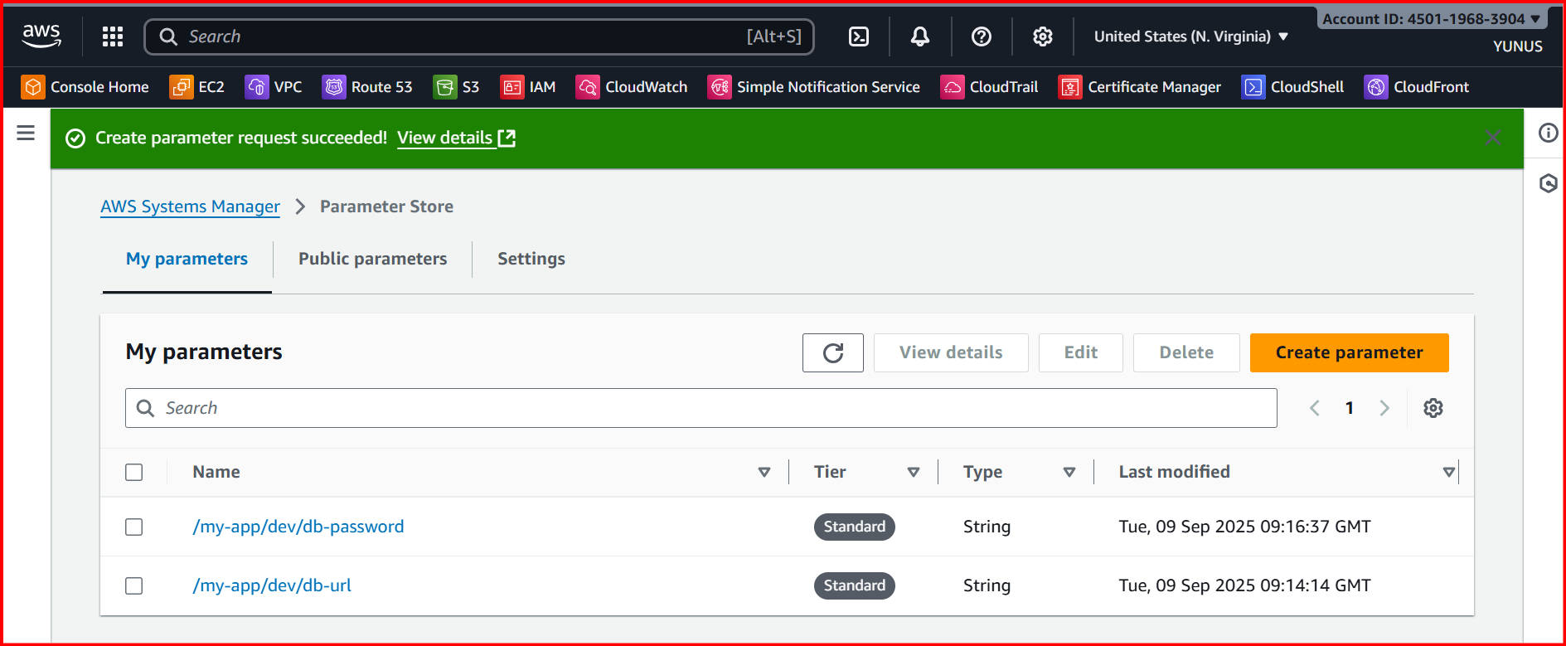

**Open cloudshell cli or any cli and get parameters  
aws ssm get-parameters --names /my-app/dev/db-url /my-app/dev/db-password**

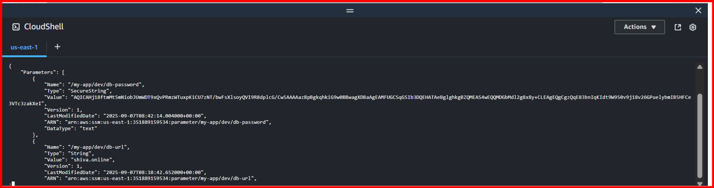

**For string we get plain text but for secure string having password came in encrypted  
Now try to decrypt we can get both url and password in plain text**

**cmnd**

**aws ssm get-parameters --names /my-app/dev/db-url /my-app/dev/db-password --with-decryption**

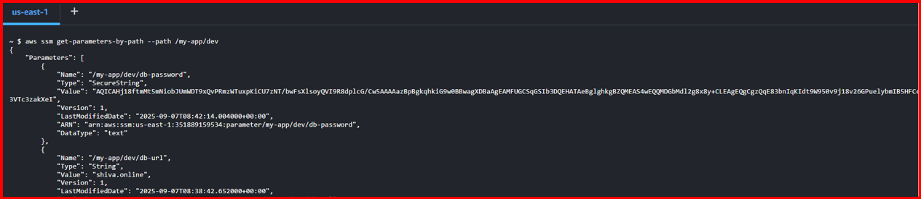

**We can get all parameters using recursive  
aws ssm get-parameters-by-path --path /my-app/ --recursive**

**Now getting all parameters in plain text using recursive decryption.  
aws ssm get-parameters-by-path --path /my-app/ --recursive --with-decryption**